**INSERT AND SELECT**

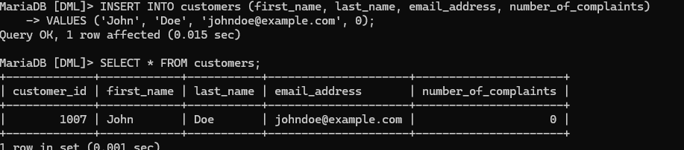

**UPDATE**

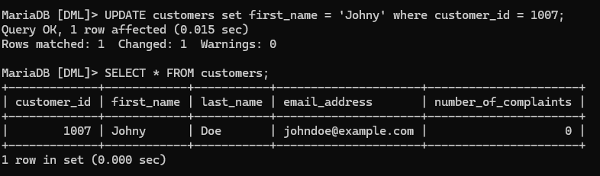

**DELETE**



**CASCADE**

